# Instructions

This is an open book and take-home exam. You may use any of your text book and notes for this exam but you may not discuss with other students and share answers. You turn in your exam before our class. Please type your answers into a separate document. I only need the answers, not the questions. Please include your name on the document and save the document as 604_mde_name in a word or pdf format.

Question 50 requires a diagram to be drawn. You may create the diagram in word or use another drawing tool (Visio, hand drawn) if preferred and either copy a print screen of the diagram into the document or upload as a separate attachment. If you have more than one document, please zip/compress into one file.

## Set up instructions:

Some questions on the midterm will include SQL questions using the TSQLV4 database from homework 3 assignment. It is optional if you want to check the SQL Query against the database to help answer the question. If needed, you can download the TSQLV4.sql file from Blackboard and run the script in Management Studio to create a database called TSQLV4 along with tables and sample data.

# Questions (questions 1-50 are 1.5 points each):

1. Return orders placed in June 2015. Tables involved: TSQLV4 database, Sales.Orders table. The output should look similar to:  
    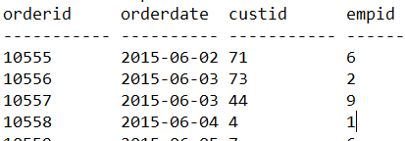  
     
   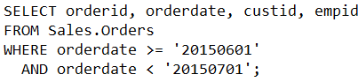
2. Return orders with total value(qty*unitprice) greater than 10000 and sorted by total value. Tables involved: Sales.OrderDetails. The output should look similar to: 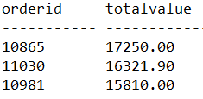  
   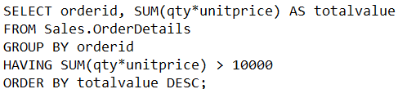
3. Return the three ship countries with the highest average freight for orders placed in 2015 Tables involved: Sales.Orders table. The output should look similar to: 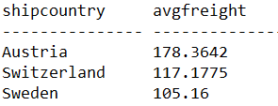  
   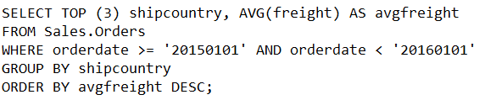
4. Write a query that returns employees who did not place orders on or after May 1st, 2016. Tables involved: TSQLV4 database, Employees and Orders tables. The output should look similar to: 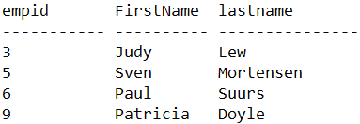  
     
   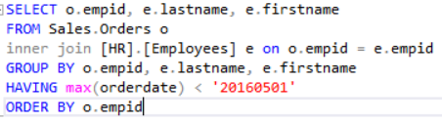
5. Write a query statement that generates 5 copies out of each employee row- Tables involved: TSQLV4 database, Employees and Nums tables. The output should look similar to: 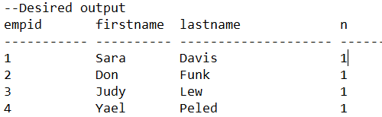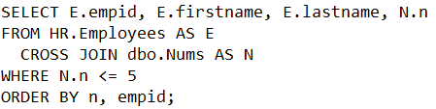
6. Explain the difference between “IN” and “Exists.”  
   Whereas the IN predicate uses three-valued logic, the EXISTS predicate uses two-valued logic. when no NULLs are involved in the data, IN and EXISTS give you the same meaning in both their positive and negative forms (with NOT). When NULLs are involved, IN and EXISTS give you the same meaning in their positive form, but not in their negative form. In the positive form, when looking for a value that appears in the set of known values in the subquery both return TRUE, and when looking for a value that doesn’t appear in the set of known values both return FALSE. In the negative forms (with NOT), when looking for a value that appears in the set of known values both return FALSE; however, when looking for a value that doesn’t appear in the set of known values NOT IN returns UNKNOWN (outer row is discarded), whereas NOT EXISTS returns TRUE (outer row returned).
7. Use a SELECT INTO statement to create and populate a new table Sales.Order14To16 with orders from the Sales.Orders that were placed in the years 2014 through 2016. 
8. Alter the table in step 7 to add an integer column called ‘FiscalYear.’ Use an UPDATE statement to set the value of FiscalYear column to equal the year the order was placed except that if the month is October, November, or December, you will add one year to the year.   
   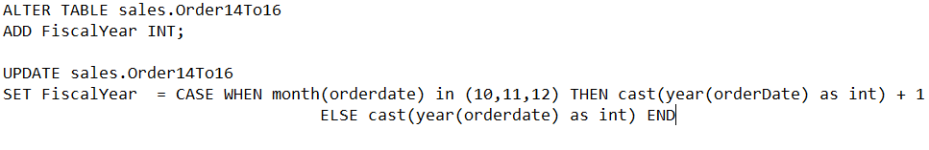
9. Optional Extra Credit Question: Return all customers, and for each return a Yes/No value depending on whether the customer placed an order on Feb 12, 2016. Tables involved: TSQLV4 database, Customers and Orders tables. The output should look similar to: 